The Java class **College** represents information about a college or university. The class defines methods for accessing a **College** object's name, tuition, and the region in which it is located; for setting the tuition; and specifies constants for naming regions.

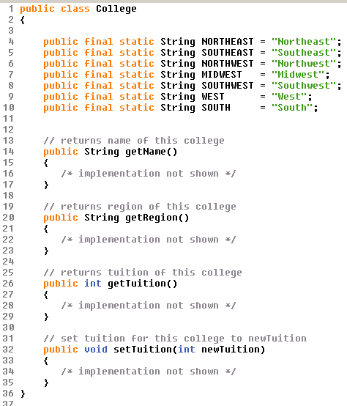

The class **CollegeGroup** stores information about a group of colleges/universities. Part of the **CollegeGroup** class declaration is shown on the next page.

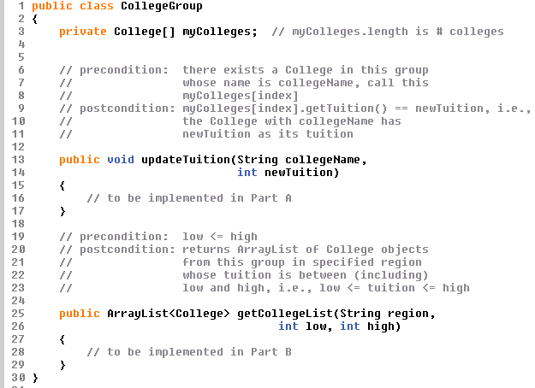

The following chart shows an example of colleges/universities that could appear in an object of type **CollegeGroup**.

|  |  |  |  |
| --- | --- | --- | --- |
|  | **Name** | **Region** | **Tuition** |
| **0** | Colgate University | Northeast | $27,025 |
| **1** | Duke University | Southeast | $26,000 |
|  |  |  |  |
| **2** | Kalamazoo College | Midwest | $19,764 |
| **3** | Stanford University | West | $25,917 |
| **4** | Florida International University | Southeast | $10,800 |
| **5** | Dartmouth College | Northeast | $27,764 |
| **6** | Spelman College | Southeast | $11,455 |
|  |  |  |  |

**Part A**

Write the **CollegeGroup** method **updateTuition**, which is described as follows. Method **updateTuition** associates a new tution with the college whose name is passed as a parameter.

Complete method **updateTuition** below.

**Part B**

The table below is repeated for your convenience.

|  |  |  |  |
| --- | --- | --- | --- |
|  | **Name** | **Region** | **Tuition** |
| **0** | Colgate University | Northeast | $27,025 |
| **1** | Duke University | Southeast | $26,000 |
|  |  |  |  |
| **2** | Kalamazoo College | Midwest | $19,764 |
| **3** | Stanford University | West | $25,917 |
| **4** | Florida International University | Southeast | $10,800 |
| **5** | Dartmouth College | Northeast | $27,764 |
| **6** | Spelman College | Southeast | $11,455 |
|  |  |  |  |

Write the **CollegeGroup** method **getCollegeList**, which is described as follows. Method **getCollegeList** returns an ArrayList of colleges that are locted in the specified region and whose tuition is in the range between **low** and **high**, inclusive. The size of the ArrayList should be equal to the number of colleges that meet the criteria of region and tuition range.

For example, if the object **colleges** is an instance of the class **CollegeGroup** and represents the entries shown in the chart above, the call

**ArrayList<College> list = colleges.getCollegeList(College.SOUTHEAST,10000,20000);**

should store in **list** an ArrayList of two elements containing objects representing Florida International University and Spelman College (note that Duke University is not included because its tuition is not in the specified range and Kalamazoo College is not included because it is not in the specified region).

Part b cont’d